**Storyboard 1**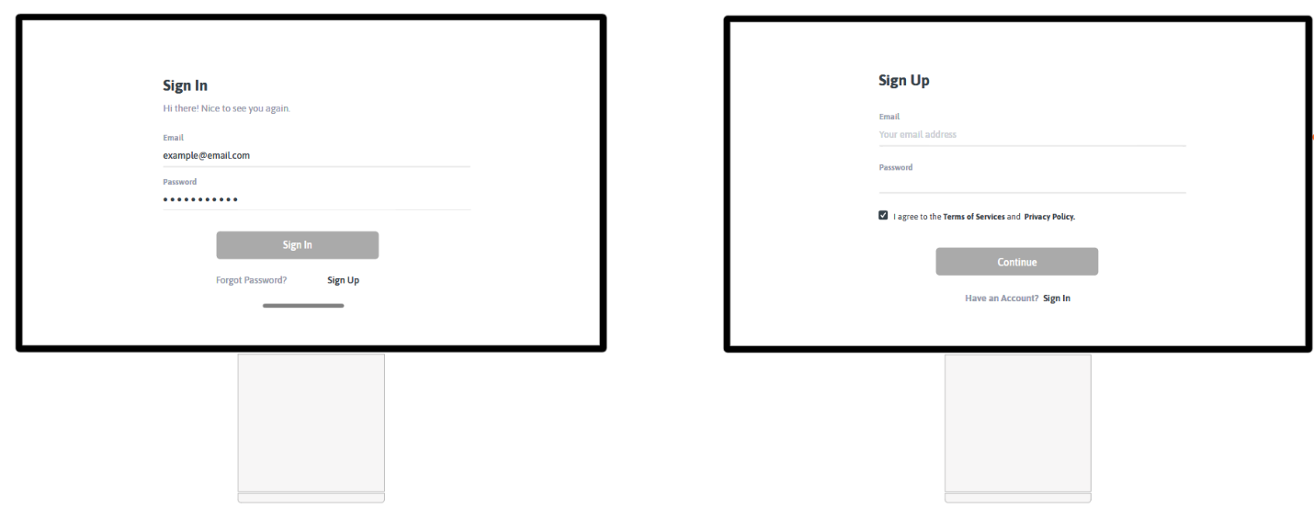

**Description: Sign In/ Sign Up**

User must first sign up on the site in order to play different games. After he signed up, he must sign in to have all the privileges. Now, he will have have access to the menu and an welcome message will be displayed.

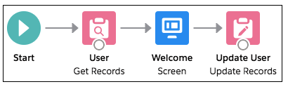

**Storyboard 2**

**Description: User navigates to Dashboard Page**

From Dashboard Page, the user can see chart with different types of charts. Examples: Gamers online, Total Games Played, Games sold, Games cretaed.

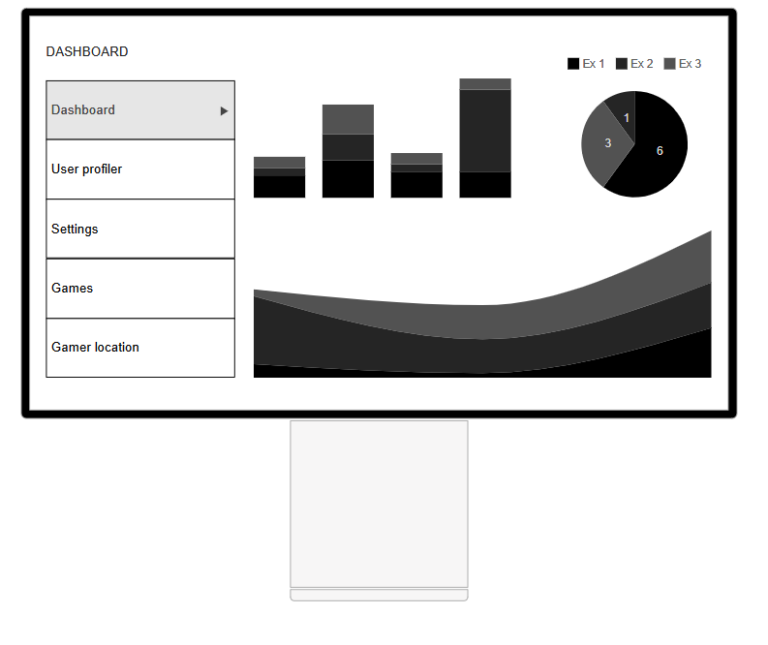

**Storyboard 3**

**Description: User navigates to User profile/Settings**

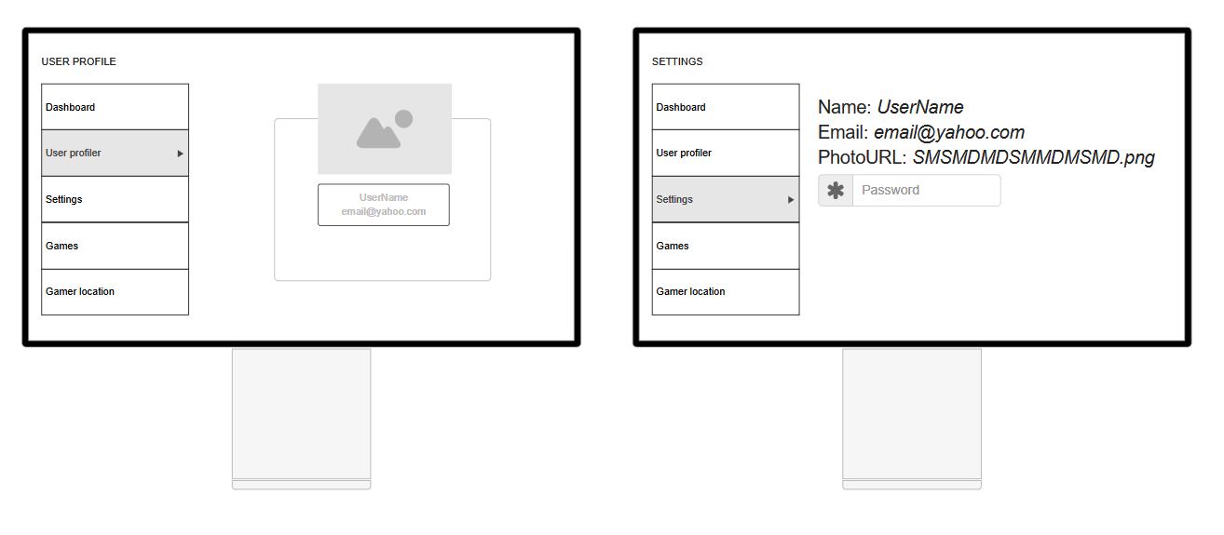

On “User profile” page, the user can edit the details that will be displayed on the profile. For example: the image of the user icon.

On Settings page, the account details can be edited. For example: the username from in game, password, email.

**Storyboard 4**

**Description: User navigates to Games/Gamer location (the location of the user will be displayed on the maps)**

On “Games” page the user can see the available games and he can play the game he chooses/rate a game.

The user can see his location of google maps by clicking the “Gamer location” in the menu.

